Governmental Body:  The City Council of Baxter, Iowa | Call In Information:  City Council Meeting – March 24, 2025, 5:30 – 5:45 PM (America/Chicago)  Please join my meeting from your computer, tablet or smartphone.  https://meet.goto.com/643387437  You can also dial in using your phone.  Access Code: 643-387-437  United States: +1 (224) 501-3412
Date of Meeting:
Monday, March 24th, 2025
Time of Meeting:
5:30 P.M.
Place of Meeting:
Baxter City Hall/Council Chambers
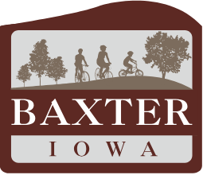

- Call to Order by Mayor Doug Bishop

- Approval of the Agenda

- Public Hearing – FY2026 Proposed Property Tax Levy Hearing

  - Mayor opens public hearing.
  - Mayor calls for public comments.
  - Mayor closes the public hearing.

- Adjournment

This notice is hereby given at the direction of the Mayor pursuant to Chapter 21.4, Code of Iowa, and the local rules of said governmental body.

AMERICANS WITH DISABILITIES ACT COMPLIANCE: IF THERE IS ANYONE WISHING TO ATTEND THE MEETING THAT MAY REQUIRE SPECIAL ASSISTANCE IN BEING ABLE TO PARTICIPATE IN THIS MEETING, PLEASE ADVISE CITY HALL OF YOUR NEEDS 48 HOURS BEFORE THE MEETING

