Governmental Body:  The City Council of Baxter, Iowa | Call In Information:  City Council Meeting – March 24, 2025, 5:30 – 5:45 PM (America/Chicago)  Please join my meeting from your computer, tablet or smartphone.  https://meet.goto.com/643387437  You can also dial in using your phone.  Access Code: 643-387-437  United States: +1 (224) 501-3412
Date of Meeting:
Monday, March 24th, 2025
Time of Meeting:
5:30 P.M.
Place of Meeting:
Baxter City Hall/Council Chambers
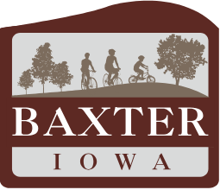

Mayor Doug Bishop called the FY26 Property Tax Levy Hearing to order at 5:30 p.m. Present were Kinzel, Kunkel, Schabilion, and Smith. Milligan was absent due to traveling. Also present were Administrator Battani, Deputy City Clerk Braye, and various members of the public.

Kinzel moved to approve the agenda. Schabillion seconded. Ayes: Kinzel, Kunkel, Schabilion, and Smith. Motion carried.

Mayor opened the public hearing. Asked the public for any comments. Mayor Bishop went through the main points of the budget, where we are saving money for FY2026.

Steve Wright 304 K street at a question related to the city sewer bond, council advised that such bond matures in 2029.

Smith motioned to Closed the FY2026 Property Tax Levy hearing. Kinzel seconded. Ayes: Kinzel, Kunkel, Schabilion, Smith. Motion carried.

Smith motioned to adjourn the property tax hearing. Kinzel seconded. Ayes: Kinzel, Kunkel, Schabilion, Smith. Motion carried. The meeting adjourned at 5:34 pm.

__________________________________________ ______________________________________
Lucas Battani, City Administrator/City Clerk Doug Bishop, Mayor

